Voluntary Class Supplies for the 2018-2019 School Year 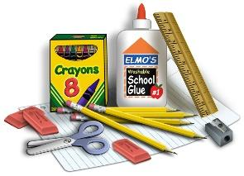
Grade Level: 3rd
Suggested Items:
8+- Fine point BLACK Expo dry erase markers
8+- Wide tip Expo dry erase markers
1- Eraser or old “clean” sock for dry erase boards
3- Composition notebooks- (the ones that are stitched, different
colors and wide ruled)
5- Plain PLASTIC folders with POCKETS & PRONGS inside (five
different colors – one is for Science)
1- Pair of pointed scissors
1- Small box of crayons (16 or 24 size)
1- Box of colored pencils and/or markers
1- Ruler (inches and centimeters)
1- Pack of pencil top erasers
1- Large glue stick
1- Pencil box to keep items in desk
1- ½ inch to ¾ inch 3-ring binder for homework WITH 15 Sheet
Protectors inside (the heavy duty sheet protectors for working
on math facts, etc…)
1- Earbuds in a container/baggie labeled with name & teacher for
Computer class
Community Items:
1- Large box of Kleenex
1- LARGE container of disinfecting wipes (Clorox, Lysol, etc…)
3- Boxes of pencils (sharpened if possible, one box is
for the ‘Specials’ Teachers’ community supplies)
1- Pack of wide ruled filler paper (100+ count)
Girls- 1- Pack of sheet protectors (heavy duty ones)
Boys- 1- Pack of colored correcting pens (NO red please)

