Voluntary Class Supplies for the 2018-2019 School Year 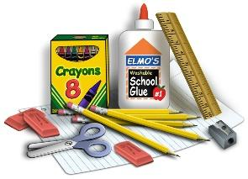
Grade Level: 4th Grade
Suggested Items:
- #2 pencils or mechanical pencil with lead refills
- crayons (12-24 count)
- 1 pack of colored pencils
- 2 colored correcting pens
- 3-4 black Expo markers (your child will need to bring in more if he/she runs out)
- 1 Magic Eraser or whiteboard eraser
- 1 ruler with inches and metric measurement (with child’s name on it)
- 1 pair of scissors (with child’s name on it)
- pencil top/Pink Pearl eraser
- 3 composition books: 1 for Writing, 1 for DOG, and 1 for Science
- 2 packages 100 count wide ruled paper
- 1 GREEN sturdy plastic pocket folder
- 1 BLUE sturdy plastic folder with THREE BRADS/PAPER FASTENERS
- 1 sturdy pocket folder—color/pattern of your choice
- 1 pencil bag or pencil box
- 1 1-inch binder
- 1-2 boxes of tissues
- 2 containers of Clorox wipes
- earbuds in a bag or container labeled with name and homeroom—these will stay in Computer class
For Specials (PLEASE LABEL THESE ITEMS “SPECIALS”)
- DeFriez’s class: 1 dozen #2 pre-sharpened pencils
- Rodeghiero’s class: 2 dry erase markers
- Obenchain’s class: 2 glue sticks
Community Items:
- Last Name A-J: glue sticks
- Last Name H-P: 1-2 black Sharpies
- Last Name Q-Z: sandwich or snack size Ziploc bags

