Job Details
Application Deadline: Posted until Filled
Posted: June 18, 2013
Starting Date: August 19, 2013
Job Description
We are now accepting applications for secondary certified teachers in Chemistry, part time.
Overview of North Star Charter School
North Star Charter School is a highly successful K-12 public school with the mission of building an environment of respect, compassion, and critical thinking that inspires civic leadership. The school is set just outside of Eagle, Idaho. The successful culmination of the K-12 program is an International Baccalaureate diploma.  At North Star Charter School, the principles that guide classroom behaviors are hard work, study smart, and have fun learning. The principles that guide personal behaviors are respect for self, respect for others, and respect for property. | 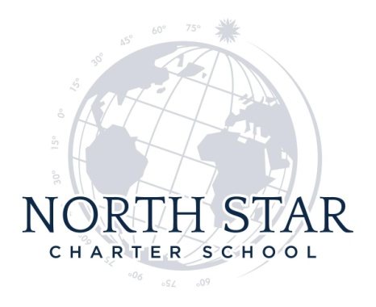

North Star Charter School is committed to maintaining a safe work and learning environment. We have developed and enforce a no bullying school and bus transportation policy.

North Star Charter School is an Equal Opportunity Employer.

Job Requirements
Educational or other qualifications required:
- Bachelor’s degree in secondary education, secondary teaching certificate, and subject matter endorsement in the state of Idaho required.
- Experience working with secondary students in a public school setting preferred.
- Demonstrated ability to work collaboratively as a member of a multi-disciplinary staff
- Strong written and oral communication skills
- Experience with Power School data base computer program
- Citizenship, residency or work VISA in United States required
Application Questions
Please answer the questions on the job application on the North Star Charter School web site, found at www.northstarcharter.org . It is highly recommended that you type any essays in a word processing program, save them, and then paste them on the job application page. Please email your resume`, North Star Charter School application materials, scanned copies of transcripts, and three letters of recommendation to Lrogien@northstarcharter.org
Contact Information
Email: Lrogien@northstarcharter.org

