North Star Charter School
Lunch program
Presented by
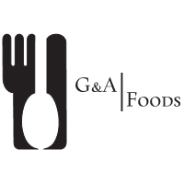

208.323.5960
Info.gandafoods@q.com

MONTH of DECEMBER
Sunday | Monday | Tuesday | Wednesday | Thursday | Friday | Saturday
 | 2  Mac and cheese, carrot sticks, cookie | 3  BBQ pork sandwich, corn, fruit salad | 4  Fajitas, beans, apple | 5  Chicken fingers, fruit salad, cookie | 6  Lasagna, green salad, apple | 7
8 | 9  Spaghetti with meat sauce, garlic bread, fruit salad | 10  Sloppy Joes, coleslaw, mashed potatoes | 11  Burger Slider w/cheese and lettuce, fries, apple | 12  Roasted chicken, red potatoes, green beans, roll | 13  Pizza pockets, carrot sticks, apple | 14
15 | 16  Corn dogs, carrots, apple | 17  Chicken pot pie over biscuit, fruit salad | 18  Chili dogs, corn, apple | 19  Tacos w/lettuce and cheese, beans, apple | 20  Chicken Alfredo, carrot sticks, cookie | 21
22 | 23  No School | 24  No School | 25  No School | 26  No School | 27  No School | 28
29 | 30  No School | 31  No School

