NSCS Microgravity Experiment Update
March 26th, 2017
Results of our Microgravity Study
On January 25th, 2017 the North Star Charter School SSEP team of students and teachers met to participate in a conference call with NanoRacks to load the minilab. Patrice Rex then express mailed the minilab to Houston, TX were it was integrated and shipped to Florida for the launch that took place on February 19th.
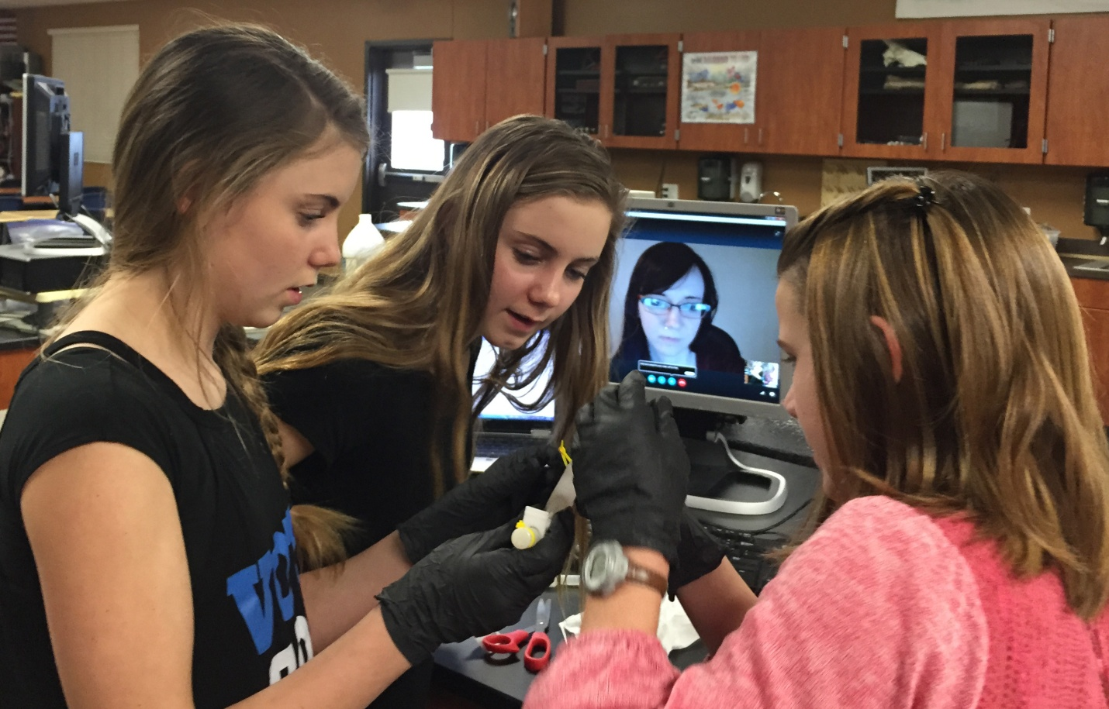
The NSCS team traveled to Florida and eagerly awaited the launch of their experiment. On February 19th , the SpaceX rocket launched from Kennedy Space Center with the North Star Charter School experiment on board.
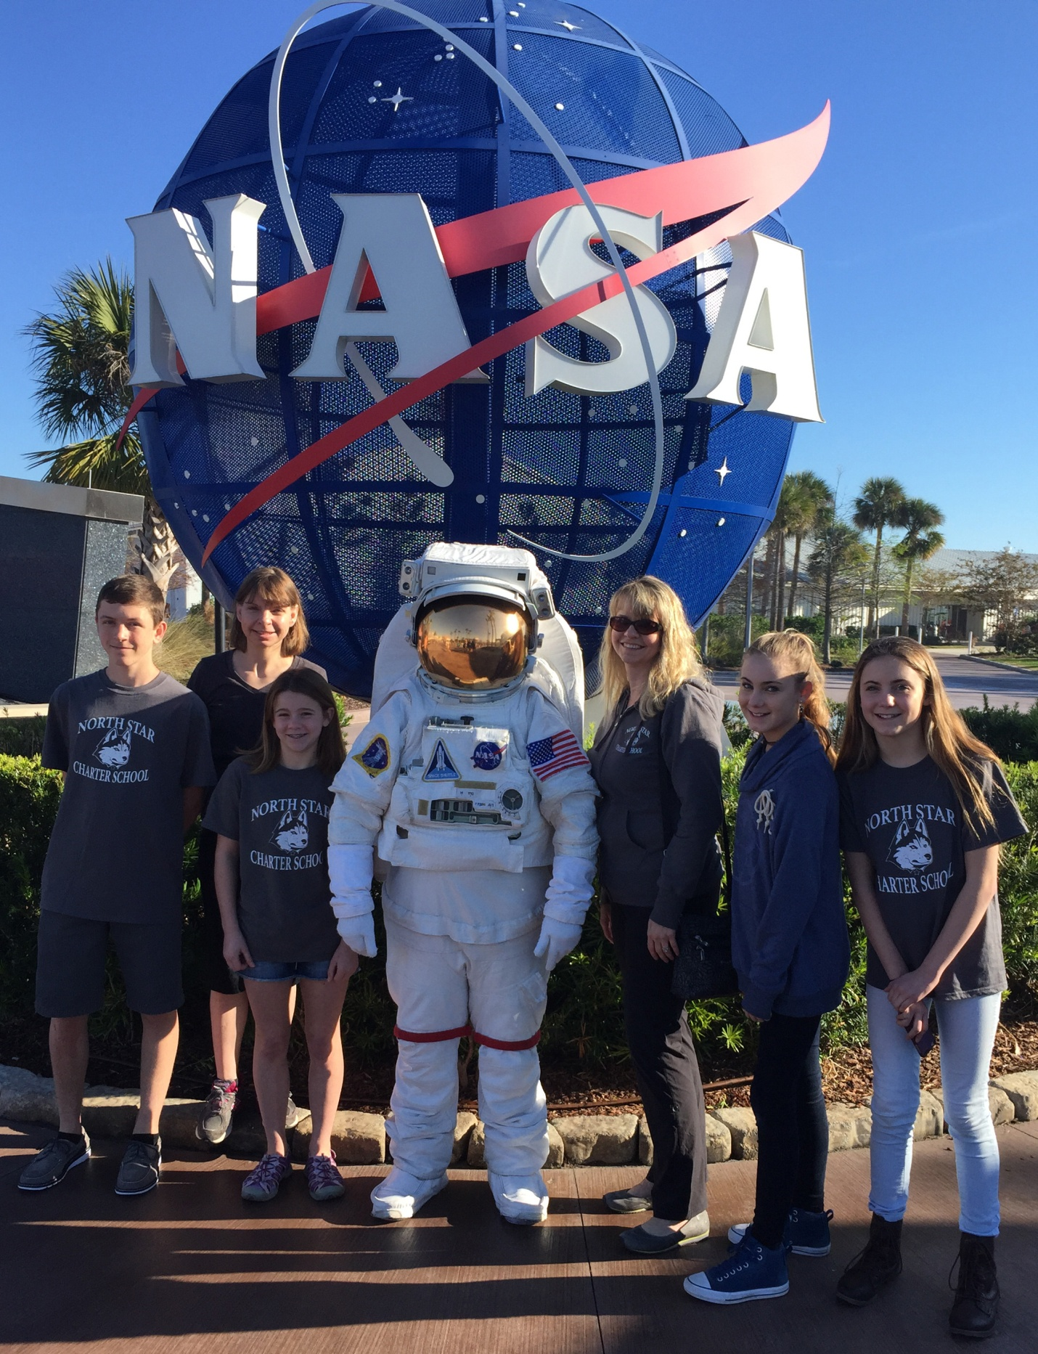
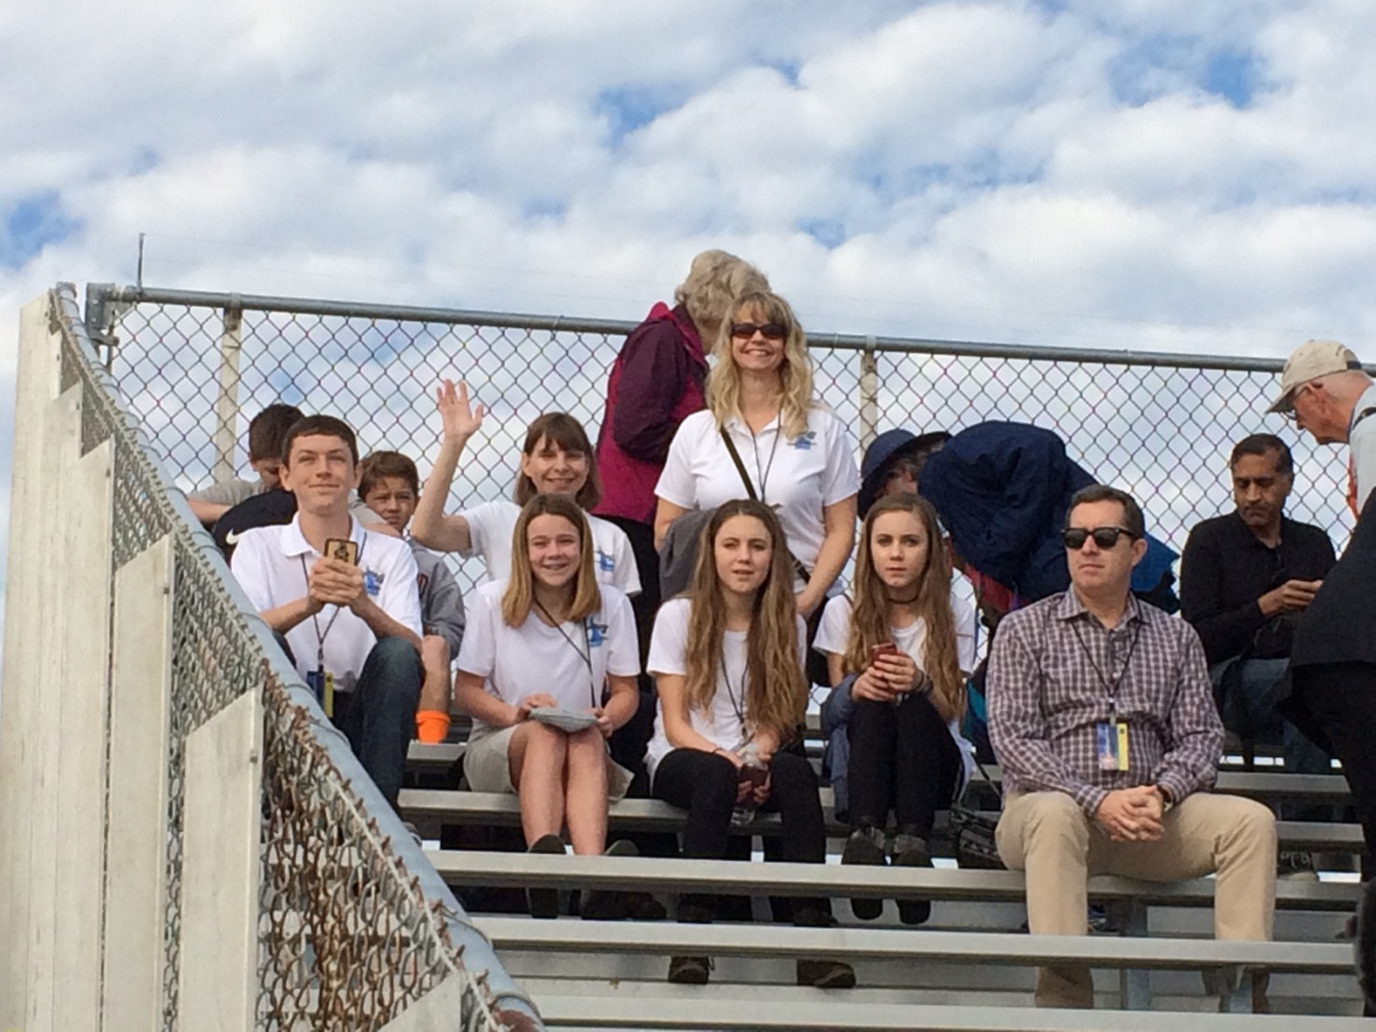
Our experiment returned to Earth on March 19th, 2017 and was returned to North Star Charter School on March 24th. On March 24th the SSEP team met scientists at the West Boise Wastewater Treatment Facility to conduct analysis on their experiment.
(Picture of students at WWTF)
What the team discovered, after the analysis was completed was that our experiment was inconclusive. The triops did not hatch in our experiment, so we were unable to determine if they were able to clean the water in microgravity. However, our experiment did point out some other areas that would provide interesting research questions for the future. Our observations of increased algae and protest growth in the environment of microgravity should be further studied. Additionally, the parallel alignment of protests that had been exposed to the microgravity environment, even after being in a 1 G environment for 5 days, is perplexing and should be further studied.
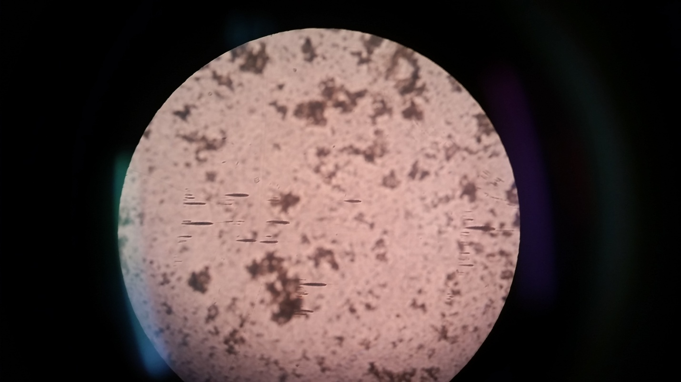
When the students and teachers were asked about what the greatest challenges they encountered during the SSEP program, this is what they had to say:

“I thought they greatest barrier was that the triops need a certain amount of water and the space requirements of the mini-lab did not allow for much water. (we were only able to use about 6 milliliters of water),” Azzio Simontacchi.

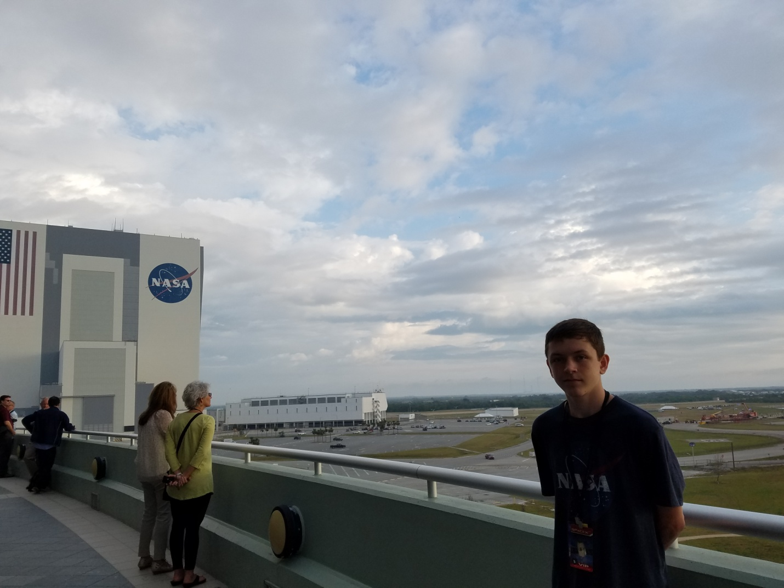

“I thought the hardest challenge was that the triops needed light to hatch. We found out that the mini-lab would have almost no light exposure on the ISS. We did have some success hatching the triops in the dark, by first exposing them to bright light,” Bostyn Corrigan.

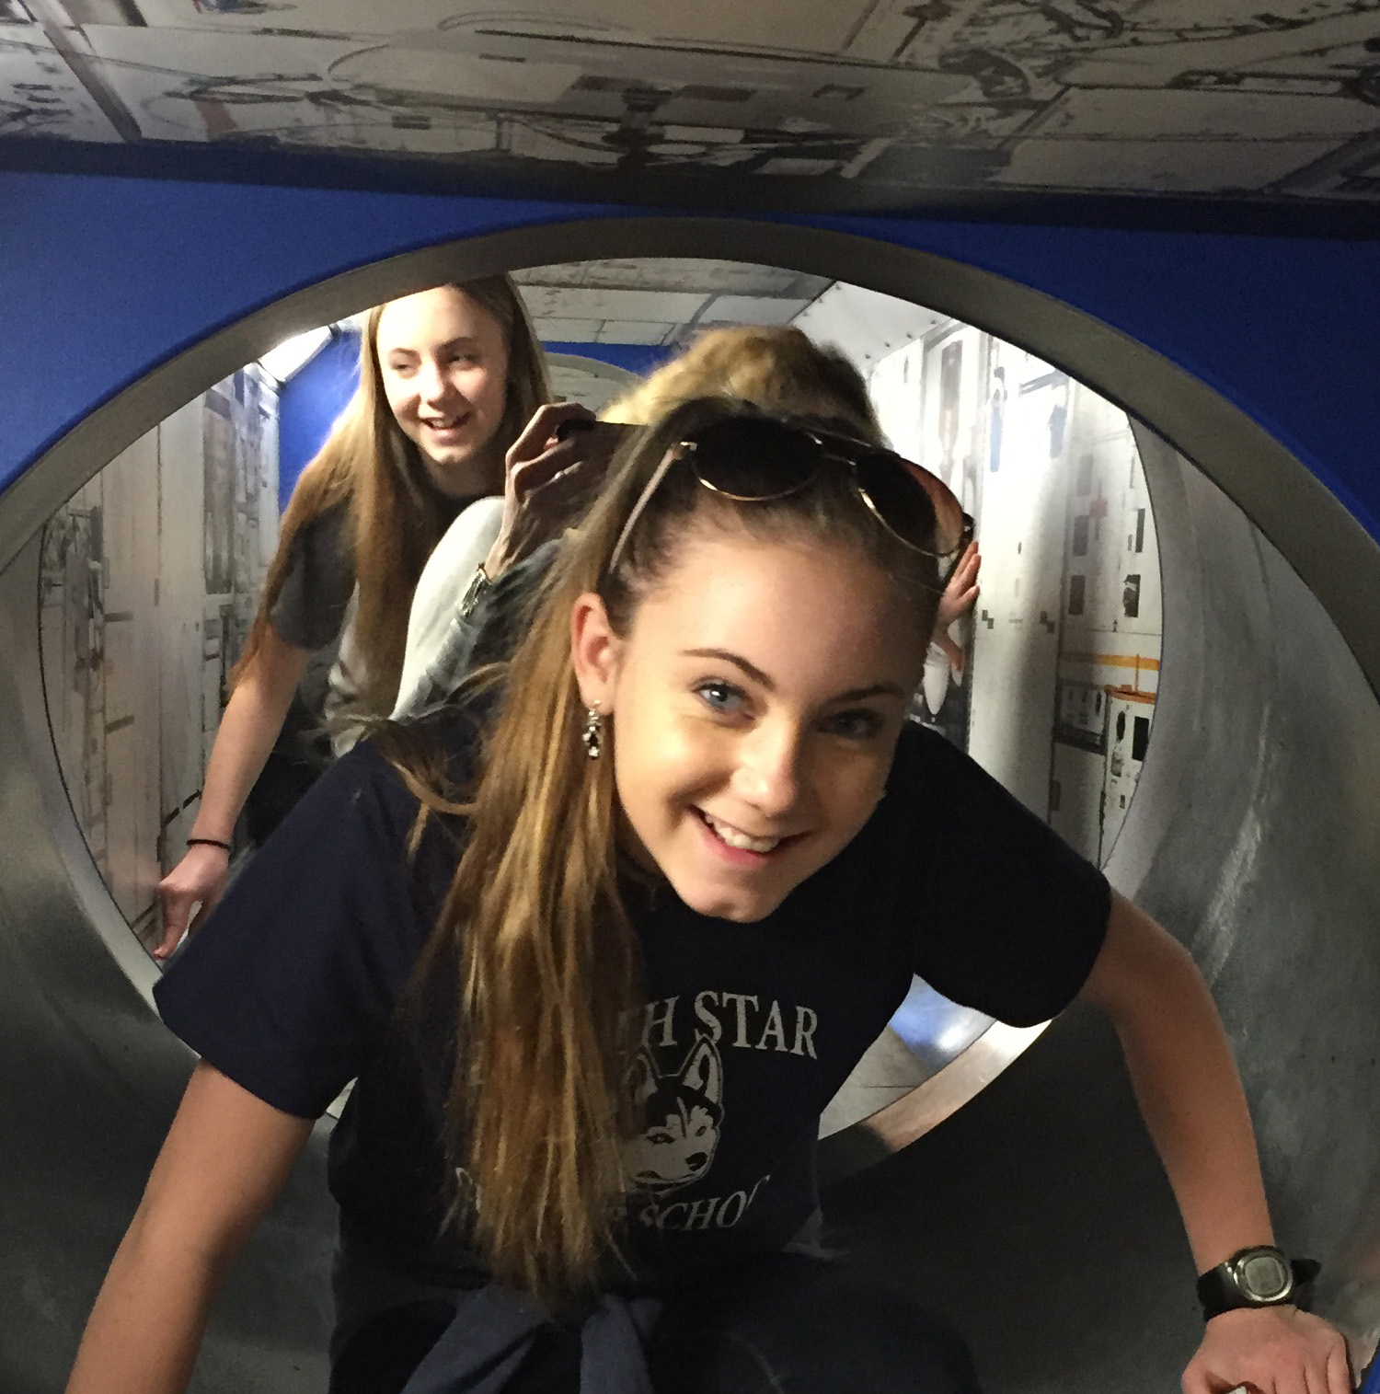

“During the time when we were experimenting, one of the major challenges was finding the right amount of exposure to light on the triops. On Earth, we were able to expose them to light before we shipped them to the ISS but then they were in darkness for several weeks again”, Madeline Clark.

So what did out students learn from their involvement in SSEP?
“We learned that if you work really hard and put in extra time to things you really want (in this case the chance to send our own experiment to space) you can achieve your goals”, Bailey Corrigan.
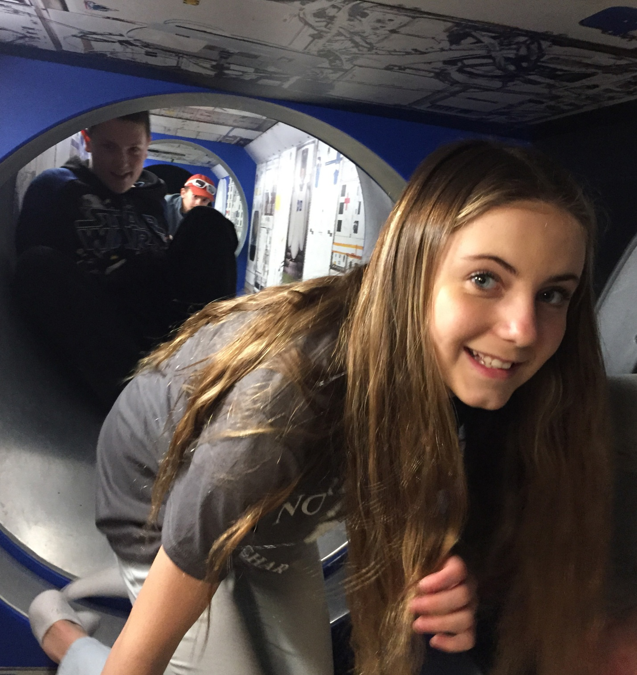

“There are often no answers to our science questions, unlike many other labs we do the teacher can tell us the outcome. This makes us have to answer our own questions through a variety of experiments,” Azzio Simontacchi.

“We learned that you aren't going to get answers the first time and after going through trial and error again and again, it may not be the answer you want to hear, it is still to be treated as valuable,” Madeline Clark.

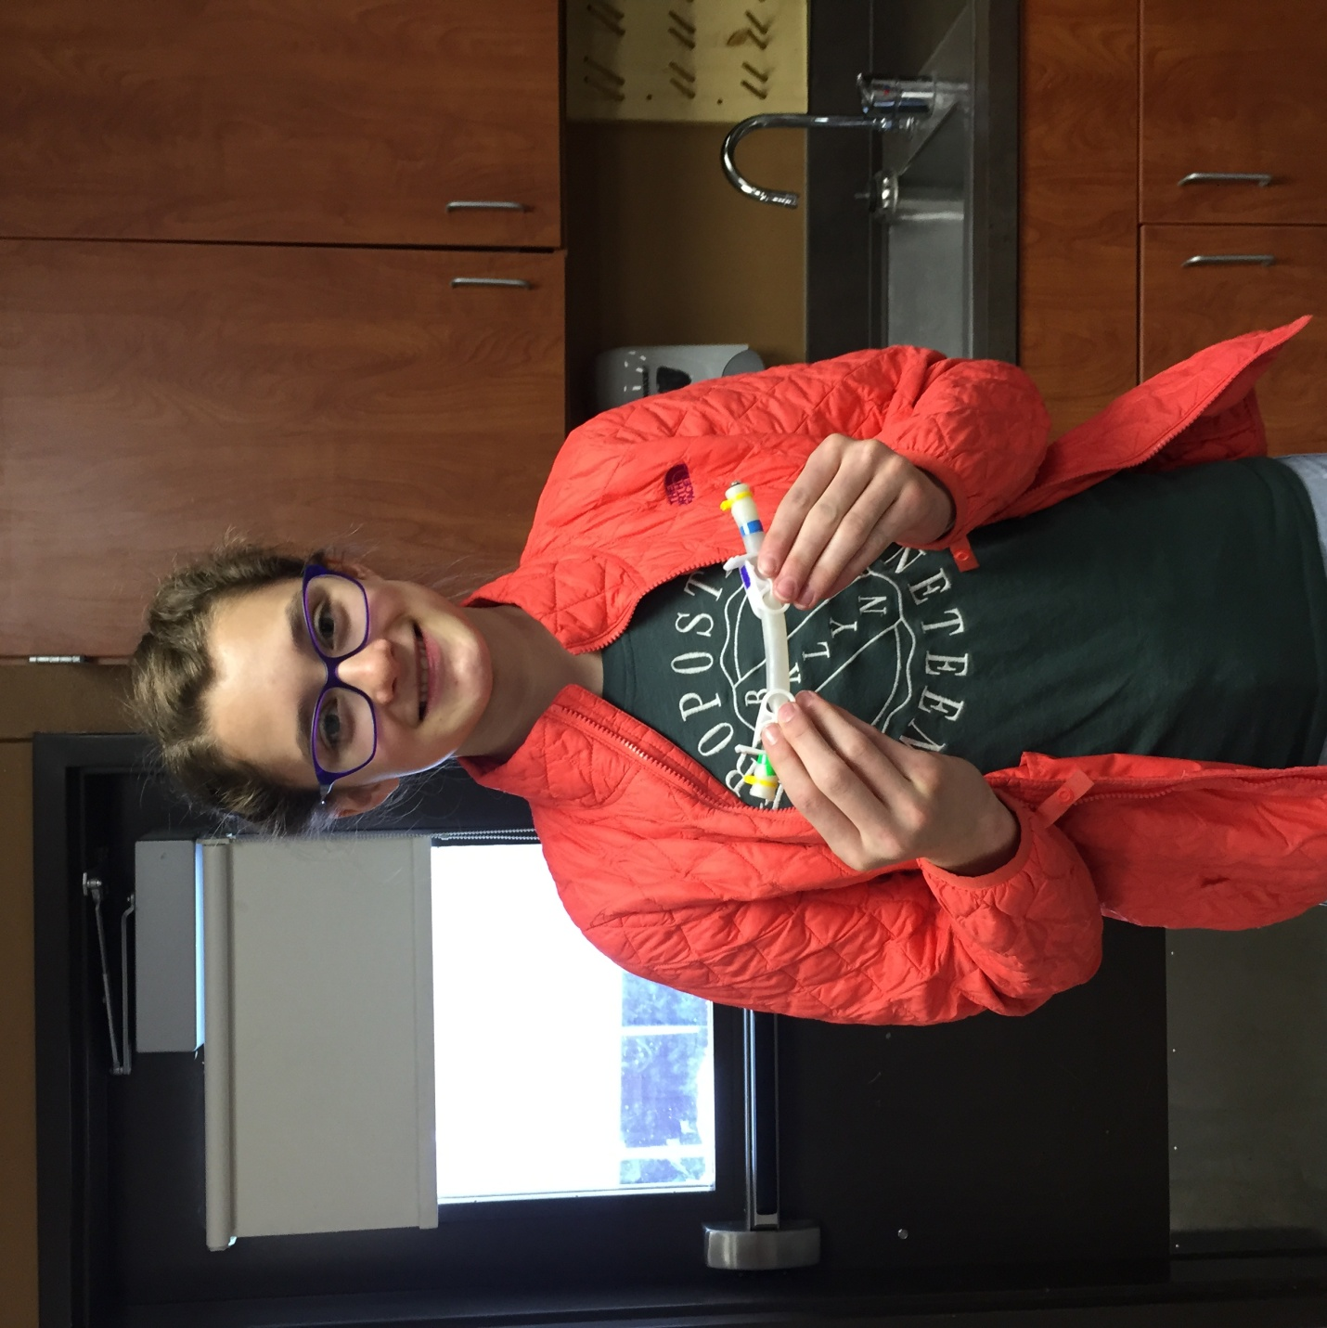

Alexandra Garvin
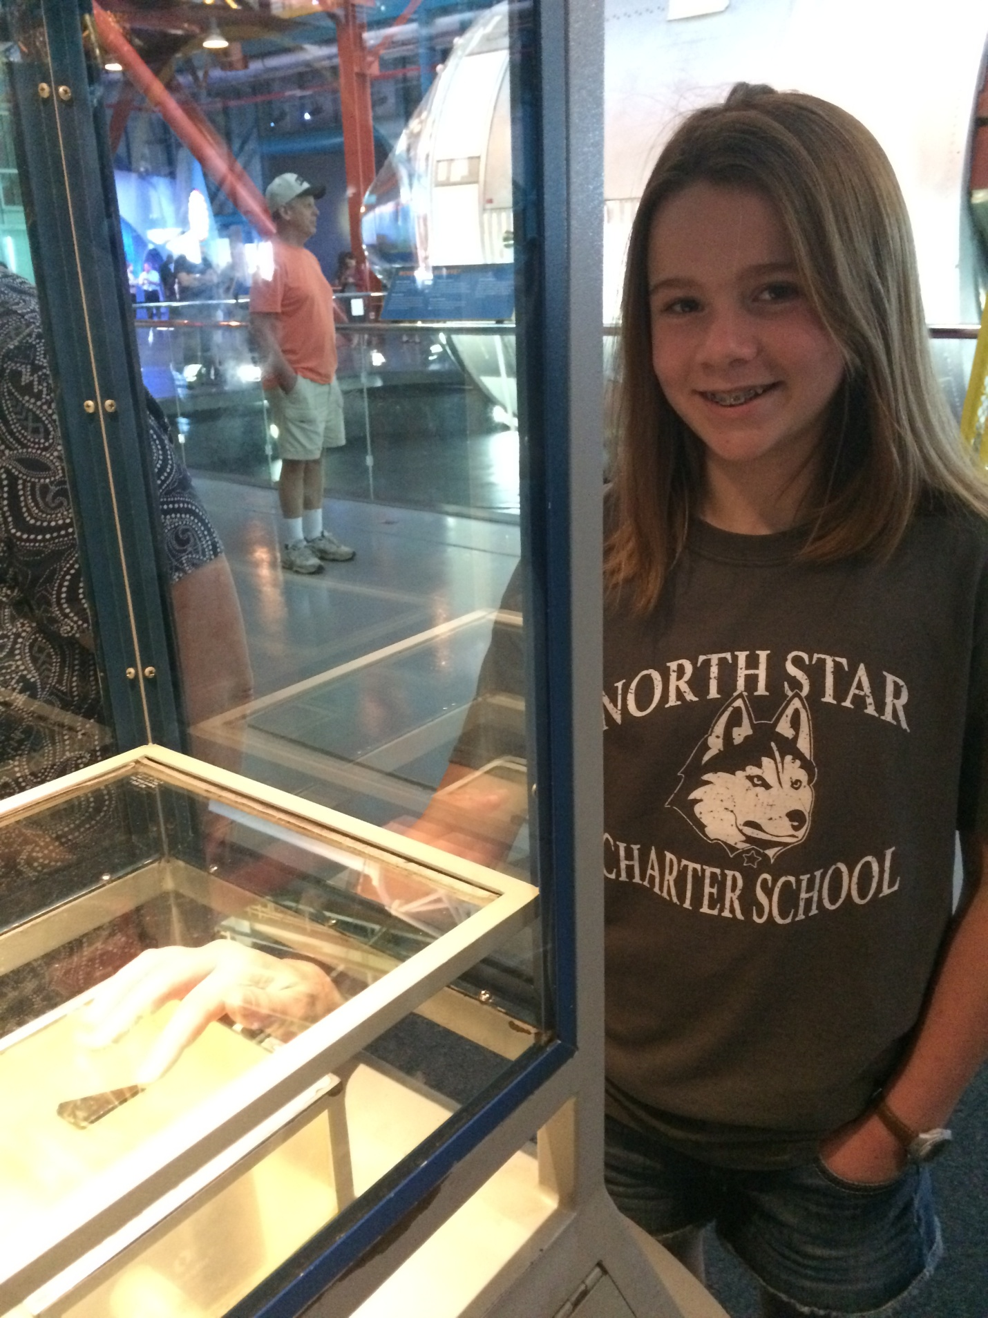
Raigen Teeter
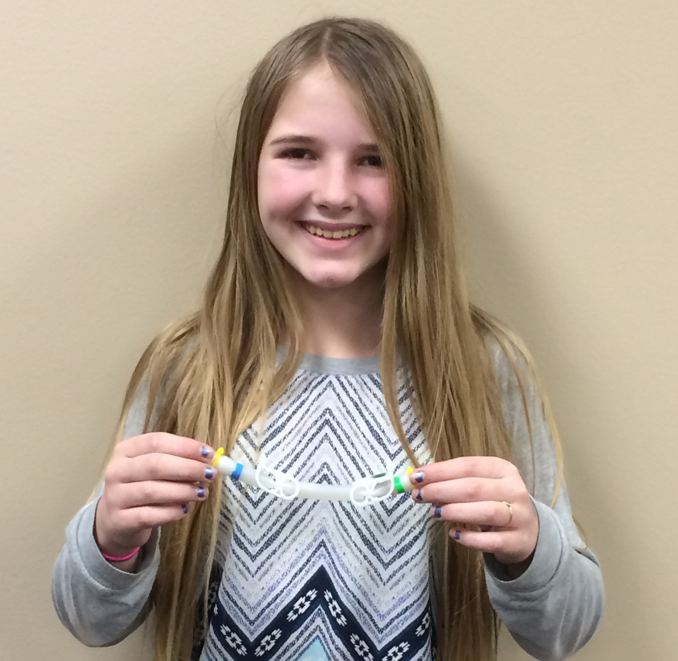

June 6th, 2017
Making a Difference in Student Empowerment in Science
You might wonder how SSEP affected the rest of the students at North Star Charter School?
The entire purpose behind my push to offer the SSEP program was a desire to provide an authentic research experience to 5-12th grade students. In the initial stages of the Student Spaceflight Experiment Project what we saw was an amazing amount of creativity employeed by our students in grades 5-12. The students found unique ways to incorporate their individual interests into their experiments and developed genuine questions that no one knew the answer to. Students engaged with experts and researchers from around the world in meaningful conversations that stemmed from genuine interest. All learners were engaged in the experience, not just gifted, advance placement, or honors students.
To expand the reach beyond the SSEP delegate team. Other students were engaged in research involving the species of organism that our research team sent to the ISS, Triops. Since Triops have been present on earth as a species for millions of years, sixth grade students developed inquiry projects around the Triops species as a part of their unit on Earth History. Student groups developed inquiry research projects on the factors that affected Triops egg hatching rates. These inquiry experiments really increase students understanding of the organisms, and helped them to feel more connected to the experiment that North Star Charter School sent to the International Space Station. After the initial experiments were over, all of the Triops were placed together in a 10 gallon tank were we were able to monitor the progress of their 8 week life span and students from various grade levels were able to stop in to see the organisms we sent to space!
We were interested in knowing if learning about our students experience with SSEP had any effect on other students’ attitudes about science or feelings of empowerment in science. To find out we created a video that summarizes the experience, and shared it with students at both North Star Charter School and a neighboring middle school. The SSEP student research video available here was presented to ten classes at North Star Charter School (3 – 7th grade classes, 1 – 6th grade class, 3 – 4th grade classes, and 3 – 5th grade classes) and to students at a neighboring middle school (2 – 6th grade classes). Each class that viewed the video was given a pre-survey prior to viewing the video and a post-survey following the video. The pre and post surveys focused on identifying the students’ attitudes and feelings of empowerment regarding science.
What we discovered was that after students viewed the SSEP student research summary video and asked questions, an increase occurred in their feelings of science empowerment. Students were more likely to believe that students like themselves could be research scientists and in their belief that a research scientist would be interested in research that students like themselves conducted.
Science Empowerment | Increase from Pre to Post-Survey for All Participating Students that Agree or Agree Strongly
Students like themselves could be research scientists | 13%
I believe that a research scientist would be interested in the results of a science study conducted by a student like myself | 11%

We also discovered an increase in student’s attitudes about science. After viewing the SSEP student research video students were more likely to feel that they were capable of doing advanced work in science.
Student Attitudes in Science | Increase from Pre to Post-Survey for All Participating Students that Agree or Agree Strongly
I am sure I can do advance work in science | 8%

It appears that the exposure to the shared experience of SSEP team through the video and question session created a stronger since of what was possible for them to achieve in science.

