Voluntary Class Supplies for the 2018-2019 School Year 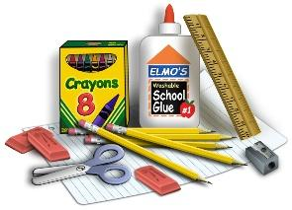
Grade Level: 5th
Suggested Items:
Backpack
1- 2” three-ring binder
3- dividers for three-ring binder (We will label in class)
2- 3-hole punch Plastic Folder with two pockets
3- Composition Notebooks (non-spiral kind)
Reinforced Quad Ruled Graphing Filler Paper (125 sheets)
College-ruled paper (100 sheets)
24 pencils- pre-sharpened pencils or box of mechanical (Ticonderoga are the BEST and made from real wood, which makes them easy to sharpen)
1 -pencil pouch that zippers up for your binder
1- box of Colored pencils
4 - fine tip, dry erase markers, any color
Scissors (please write name on them)
2 glue sticks
1 ruler that measures metric and inches
5 colored correcting pen
1 box of Kleenex (Last name A-L)
1 package of Clorox Wipes (Last name M-Z)
1 small handheld pencil sharpener
1 earbuds or headphones (for computer class)
1 Child wearing deodorant :)
1 Positive Attitude that is prepared for one fantastic year
Speciality Teachers Need Please:
5th Loos: 1 (additional) hand pencil sharpener
5th Lavin: 1 box gallon zipper sandwich bags
5th Moats: 1 box zipper sandwich bags

