Voluntary Class Supplies for the 2018-2019 School Year 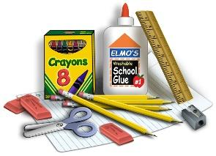
Grade Level: First
Suggested Items:
Full-size backpack
ONE 1 inch, 3-ring white binder
1 pencil box (not bag) Not Trumble’s Class
1 package of washable markers
2 boxes of 24 count crayons
1 pair scissors (pointed)
6-8 black Expo Dry Erase Markers (Fine Tip) Not Trumble’s Class
1 eraser for dry erase markers (could be a sock) Massimino Only
1 highlighter Massimino Only
1 box sharpened colored pencils
1 plastic pocket folder
1 composition book (wide-ruled), 2 for Trumble
2 dozen #2 sharpened pencils (Please no decorative)
Kleenex tissues
4 colored Expo markers (thick tip) Black only for Trumble
6 glue sticks
1 bottle Elmer’s glue, Not Trumble’s class
1 box Ziploc bags
(Last name A-M gallon size) None for Trumble
1 box Ziploc bags
(Last name N-Z quart size) All Trumble students please bring quart size
1 large container Clorox wipes
1 box Band-Aids
Specials Teachers: 1 Box of Kleenex
Computers: Ear buds (in baggie or container labeled with name)

