Voluntary Class Supplies for the 2018-2019 School Year 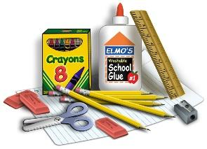
Grade Level: Second Grade
Suggested Community Items: Please NO names on these items
12 pencils – (last longer & sharpen better. Please have 5 pre-sharpened.)
1 package pencil-top erasers
12 skinny (fine tip) Expo dry erase markers
4 Regular (chisel tip) Expo dry erase markers
3 sturdy plastic pocket folders with 3 prongs
Boys: blue, green, red Girls: purple, orange, yellow
1 black fine point Sharpie (not ultra-fine)
12 glue sticks
1 large Box of Kleenex
50 heavy weight sheet protectors (sturdy ones)
1 container of Clorox wipes
1 roll of absorbent paper towels (Bounty or Kirkland brands preferred)
Suggested Personal Items: Please put names on these items
1 – 1 inch 3-ring white binder with clear plastic cover sheet
1 – WIDE ruled composition book (heavy cardboard cover, not plastic)
1 package of 8 binder dividers with pockets
1 package WIDE ruled reinforced notebook paper – pack of 150
1 white board eraser (or an old sock)
1 box of 24 crayons
1 – 12 inch ruler (with centimeters on one side)
1 pair of scissors
1 plastic pencil box (approx. 9x6 inches)
1 plastic or cloth place-mat (for lunch)
Drain- pack of 4 highlighters
Holt – 1 package of white cardstock
GC2 – Large bottle of hand sanitizer
For Science: Drain – 2 glue sticks For Computer : Earbuds
Holt - box of 24 crayons
GC2 - box of 24 crayons

