Voluntary Class Supplies for the 2018-2019 School Year 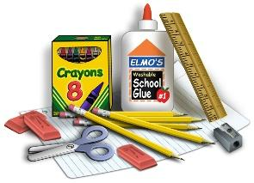
Grade Level: Kindergarten--Full day
Suggested Items:
- (75+) Heavy Duty CLEAR sheet protectors
- (4) 3-prong PLASTIC folders (Red, blue, black & any color Mead 5-Star preferred)
- (3) 3-ring (white) binders with clearview front (Share, Science, & LA)
- (1) Primary composition journal (with picture space and dotted writing lines)
- (1) A-Z tab dividers (colored individual tabs please)--place in 3-prong blue folder)
- (2) 8 tab dividers (place 8 in 2 of 3-ring binders)
- (1) 100+ count white cardstock
- (12) #2 pencils
- (1) 12 count colored pencil
- (1) 24 count crayons
- (2) color markers (1 thick set , 1 thin set )
- (12) dry erase markers (fine tip)
- (1) dry eraser (microfiber cloth works excellently)
- (2) bottles of Elmer’s glue
- (9) fat glue sticks
- (1) 6” pointed scissors
- (1) 1 metal pencil box
- (1) box of kleenex
- (3) Large containers antibacterial wipes (2 for class;1 for science)
- (1) large box gallon size ziplock baggies
Wish List
Fun bandaids
Ziplock baggies (quart/snack)
Scrapbook paper
Colored Cardstock
Mr Sketch Scented markers
Black Sharpies
Wish List

Bandaids
Ziplock baggies (gal/quart/snack)
Scrapbook paper
Colored cardstock

