Voluntary Class Supplies for the 2018-2019 School Year 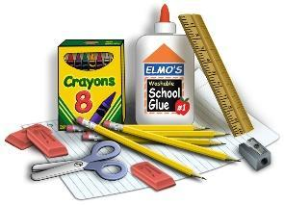
Grade Level: Half Day KINDERGARTEN
Suggested Items:
🔲(50) HEAVY DUTY clear sheet protectors
🔲(3) Mead 5 star plastic 3 pronged folders w/pockets (blue/red/black)
(1) white 3 ring binder (1 ½ inch) with clearview front and back.
🔲(1) pack of 5 divider tabs (write on tab please)
🔲(1) pair of pointed scissors (name written on them & put in pencil box)
🔲(12) sharpened #2 pencils (put in pencil box)
🔲(5) broad tip Expo dry erase markers
🔲(1) pack of 6 large glue sticks (not the thin small ones)
🔲(1) box Crayola crayons--24 pack (name written on them & put in pencil box)
🔲(1) box of kleenex
🔲(1) bottle of white Elmers glue
🔲(1) package of 100+: sheets of white cardstock
🔲(1) package of 50+: sheets of colored cardstock (black &/or primary colors please)
🔲(1) snap top plastic pencil box (name written on it)
🔲(1) Large container of antibacterial Wipes
🔲(1) primary composition journal (with picture space and writing lines) AM kinder only
Last Name A-M Last Name N-Z
- Box of thick tip Crayola color markers ⬜ watercolor paint (8 pack)
- Box of band aides ⬜ quart or gallon size zip top baggies
- Box of snack-size zip top baggies ⬜ Large bottle of Hand Sanitizer
- A two pack of black sharpie pens ⬜ colored pencils
Wants: Mr. Sketch scented poster markers, Pencil Top Erasers

