Voluntary Class Supplies for the 2019-2020 School Year 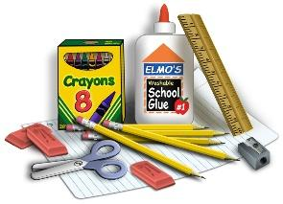
Grade Level: Fifth Grade
In order to make your child’s school year successful, the below items would greatly be appreciated:
Backpack
1- 2” three-ring binder (zipper if you prefer)
3- dividers for three-ring binder (We will label in class)
3- 3-hole punch Plastic Folder with two pockets
3- Composition Notebooks (non-spiral kind)
2- 4” Quad Ruled Composition Notebook
College-ruled paper (100 sheets)
24 pencils of pre-sharpened Ticonderoga pencils or box of mechanical (Ticonderoga are the BEST and made from real wood, which makes them easy to sharpen)
1 -pencil pouch that zippers up for your binder
1- box of Colored pencils (please write name on them)
4 - fine tip, dry erase markers, any color
Scissors (please write name on them)
2 glue sticks
1 colored correcting pen
1 box of Kleenex
1 Container of Clorox Wipes
1 small pencil sharpener
1 earbuds or headphones (for computer class)
Additionally- Specialty Teachers Need Please:
5th Loos: 1 (additional) hand pencil sharpener

5th Lavin: 1 box gallon zipper sandwich bags

5th Moats: 1 box zipper sandwich bags

